RUSTHALL PARISH COUNCIL

CO-OPTION OF A COUNCILLOR

If you are interested in becoming a Parish Councilor, information can be found on the Council’s website: rusthallparishcouncil.org.uk
or by calling 01892 520161

Closing date for applications will be NOON on
Friday 13th September 2024
Co-option will take place at the meeting of the council due to be held on Monday 14th October 2024.

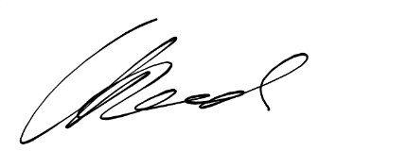
Claire Reed (Mrs)
Clerk to Rusthall Parish Council

